https://hero-logistic-update.netlify.app/sales/follow-ups - does not create task
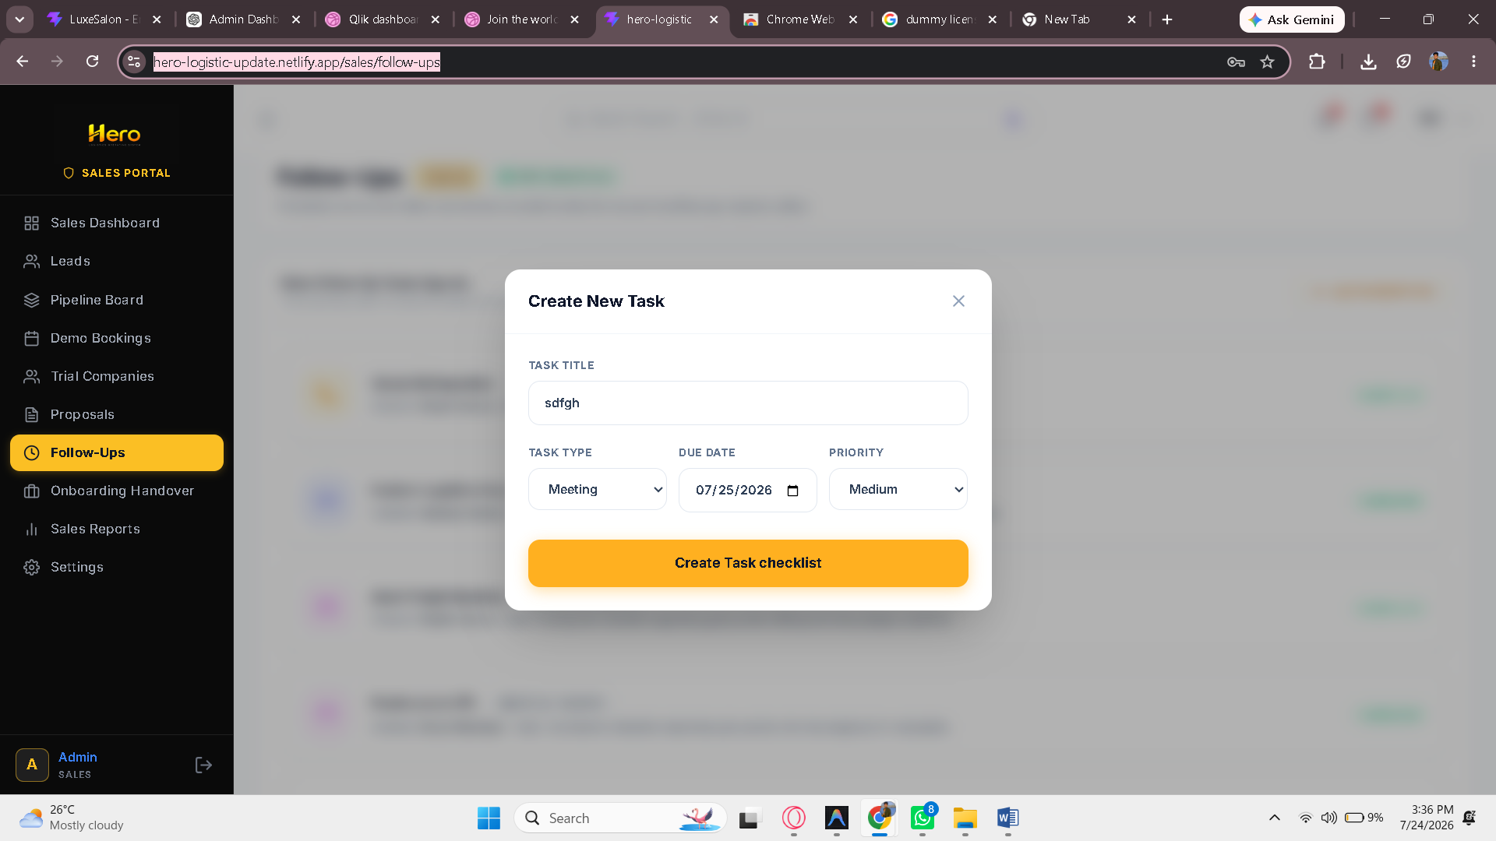

https://hero-logistic-update.netlify.app/dispatcher/loads- check required time input field
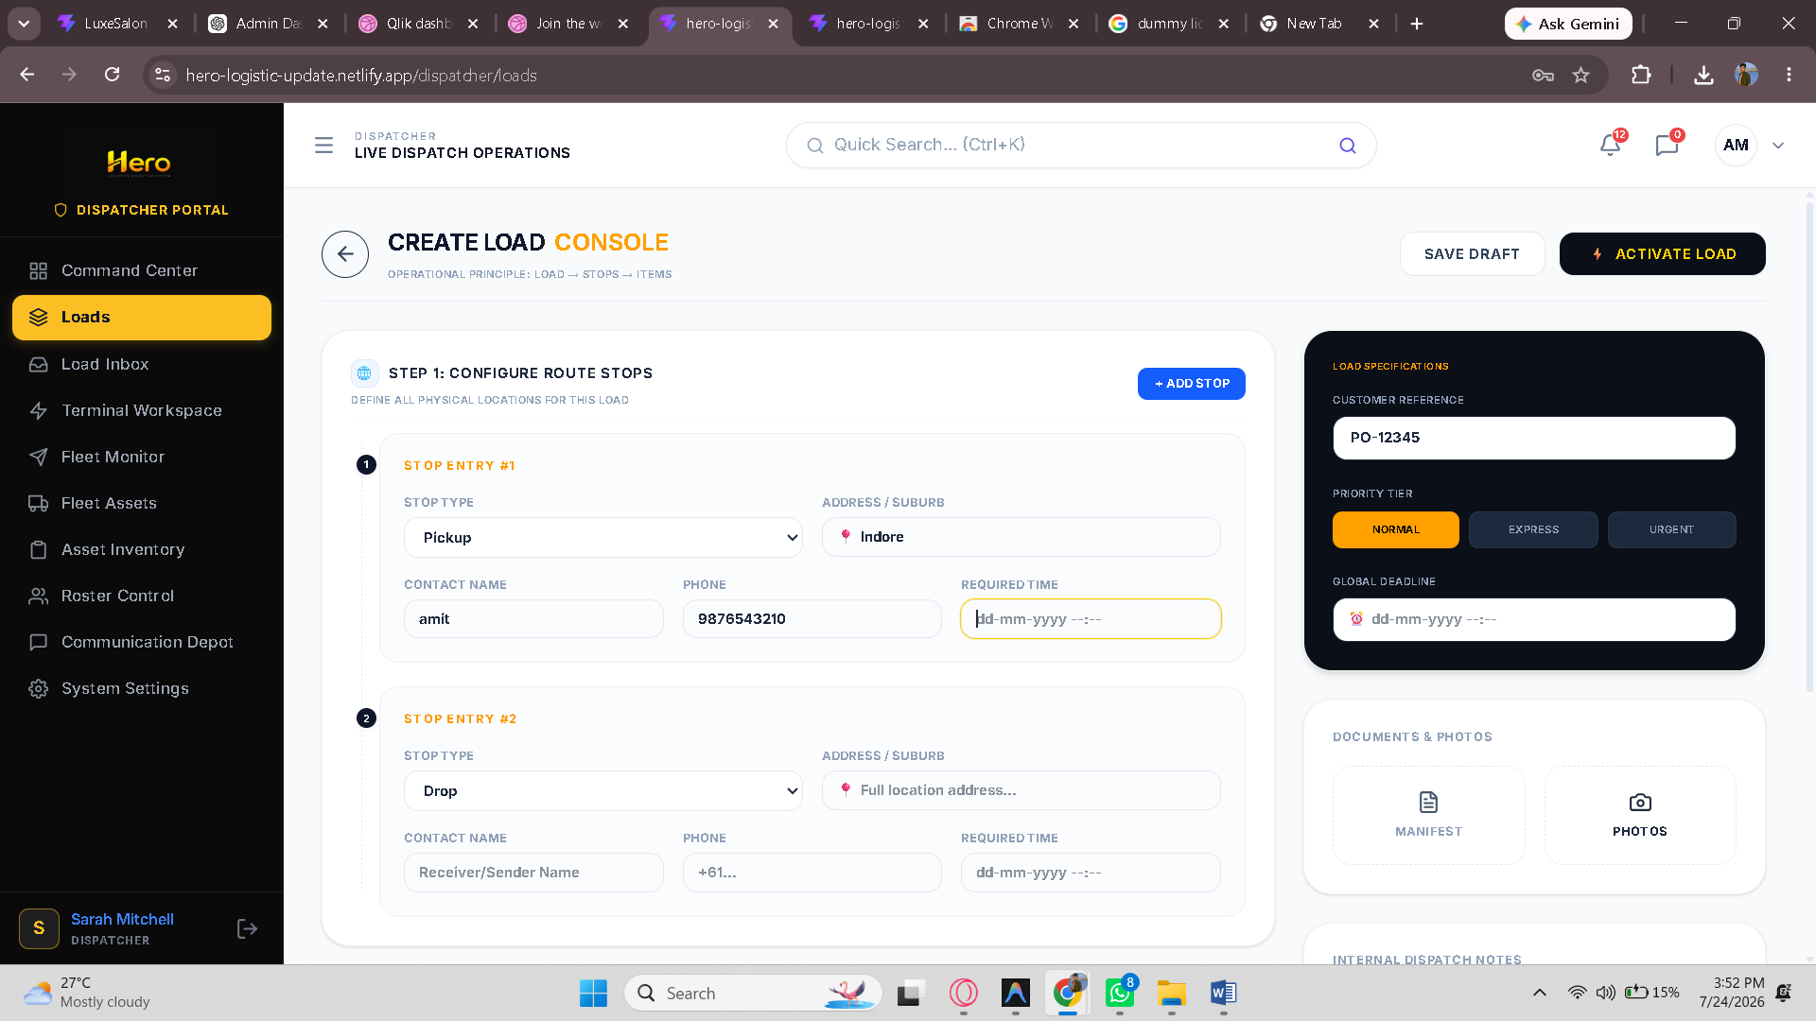

https://hero-logistic-update.netlify.app/warehouse/dashboard - filter does not works
